# **Regional Course on Statistics on Informality:**

# Definitions, Measurement, SDGs and Other Policy Indicators

# 15-18 November 2023, Chiba, Japan

# Group work (session 3.3) – Indicators and diagnostic of informality

# Elements for a national diagnosis of informality in Abelina

# **Trends, magnitude and composition of the informal economy**

Abelina has been on a sustained path for economic growth since 2015 when economic reforms were introduced in this country. In the years preceding the 2020 Covid-19 crisis, the Abelina’s economy was among the fastest growing in the world, with annual real growth in GDP averaging about 8 per cent in 2018–2023. Since 2020, Abelina experienced sharp economic slowdown. Today, even though the number of businesses increases, job creation rates decrease. In 2023, the number of registered labour of newly established businesses decreased in all regions of the country compared to previous years.

It is estimated that in 2023 more than 65 per cent of people aged 15 and over are either employed or unemployed. Close to 9 per cent of the employed in the agricultural sector, 19 per cent in industry and 72 per cent in services. According to the distribution of employment by status in employment, 56.6 per cent of all workers are employees, 38.3 per cent are own-account workers, 3.3 per cent are employers and 1.8 per cent are contributing family workers.

The proportion of workers in informal employment represents 56,8 per cent of the employed population, most of them work in the informal sector. Still a significant proportion of employees in informal employment work in formal sector enterprises but without having an effective access to social security or other employment benefits such as paid annual leave or paid sick leave. Employees represent nearly one third of total informal employment but their share tends to increase over time.

Table 1 below provides for 2023 the proportions of workers in informal employment total and respectively in informal sector enterprises and outside of informal sector enterprises including and excluding agriculture.

1. Incidence of informal employment: Distribution of total employment by formal and informal main jobs and formal-informal sector or households by employment by sector and by sex (percentage, 2023)

|  |  |  |  |  |  |  |  |
| --- | --- | --- | --- | --- | --- | --- | --- |
|  |  | Total |  | Agriculture | Total non-agriculture | Industry | Services |
| Total | **Total informal employment** | **56,8** |  | **87,4** | **53,6** | **54,1** | **53,5** |
|  | In the informal sector | 45,1 |  | 85,9 | 40,9 | 49,8 | 38,4 |
|  | In the formal sector | 6,2 |  | 1,6 | 6,7 | 4,4 | 7,4 |
|  | In households | 5,5 |  | 0,0 | 6,1 | 0,0 | 7,7 |
|  | **Total formal employment** | **43,2** |  | **12,6** | **46,4** | **45,9** | **46,5** |
| Male | **Total informal employment** | **59,5** |  | **87,9** | **54,7** | **61,3** | **51,8** |
|  | In the informal sector | 53,6 |  | 86,6 | 48,1 | 57,3 | 44,0 |
|  | In the formal sector | 5,3 |  | 1,2 | 6,0 | 4,0 | 6,8 |
|  | In households | 0,5 |  | 0,0 | 0,6 | 0,0 | 0,9 |
|  | **Total formal employment** | **40,5** |  | **12,1** | **45,3** | **38,7** | **48,2** |
| Female | **Total informal employment** | **52,7** |  | **81,5** | **52,3** | **23,9** | **55,3** |
|  | In the informal sector | 32,0 |  | 74,9 | 31,3 | 18,1 | 32,7 |
|  | In the formal sector | 7,7 |  | 6,6 | 7,7 | 5,8 | 7,9 |
|  | In households | 13,1 |  | 0,0 | 13,3 | 0,0 | 14,7 |
|  | **Total formal employment** | **47,3** |  | **18,5** | **47,7** | **76,1** | **44,7** |

Source: NSO Abelina, Integrated labour force survey 2023.

Table 2 provides some indication of the share and composition of informal employment by main employment statuses.

1. Incidence of informal employment: Distribution of total employment by formal and informal main jobs and formal-informal sector or households by employment status and by sex (percentage, 2023)

|  |  |  |  |  |  |  |  |  |
| --- | --- | --- | --- | --- | --- | --- | --- | --- |
|  |  | Total |  | Employees | Independent workers | Employers | Own-account workers | Contributing family workers |
| Total | **Total informal employment** | **56,8** |  | **29,9** | **91,5** | **52,1** | **94,9** | **100,0** |
|  | In the informal sector | 45,1 |  | 9,9 | 91,5 | 52,1 | 94,9 | 81,1 |
|  | In the formal sector | 6,2 |  | 10,4 | 0,0 | 0,0 | 0,0 | 18,9 |
|  | In households | 5,5 |  | 9,7 | 0,0 | 0,0 | 0,0 | 0,0 |
|  | **Total formal employment** | **43,2** |  | **70,1** | **8,5** | **47,9** | **5,1** | **0,0** |
| Male | **Total informal employment** | **59,5** |  | **25,8** | **90,8** | **51,9** | **94,4** | **100,0** |
|  | In the informal sector | 53,6 |  | 14,0 | 90,8 | 51,9 | 94,4 | 83,9 |
|  | In the formal sector | 5,3 |  | 10,6 | 0,0 | 0,0 | 0,0 | 16,1 |
|  | In households | 0,5 |  | 1,1 | 0,0 | 0,0 | 0,0 | 0,0 |
|  | **Total formal employment** | **40,5** |  | **74,2** | **9,2** | **48,1** | **5,6** | **0,0** |
| Female | **Total informal employment** | **52,7** |  | **34,4** | **93,4** | **53,0** | **96,1** | **100,0** |
|  | In the informal sector | 32,0 |  | 5,4 | 93,4 | 53,0 | 96,1 | 79,7 |
|  | In the formal sector | 7,7 |  | 10,2 | 0,0 | 0,0 | 0,0 | 20,3 |
|  | In households | 13,1 |  | 18,8 | 0,0 | 0,0 | 0,0 | 0,0 |
|  | **Total formal employment** | **47,3** |  | **65,6** | **6,6** | **47,0** | **3,9** | **0,0** |

Source: NSO Abelina, Integrated labour force survey 2023.

1. Distribution of formal and informal employment by main employment status including and excluding agriculture; and by sex (2023)

|  |  |  |  |  |  |  |  |
| --- | --- | --- | --- | --- | --- | --- | --- |
|  |  |  |  | Status in employment | |  |  |
|  |  | Total |  | **Employees** | **Employers** | **Own-account workers** | **Contributing family workers** |
| Agriculture | Formal employment | 100,0 |  | 94,3 | 4,2 | 1,4 | 0,0 |
|  | Informal employment | 100,0 |  | 11,4 | 3,4 | 82,1 | 3,1 |
|  | Total | 100,0 |  | 21,8 | 3,5 | 72,0 | 2,7 |
| Non agriculture | Formal employment | 100,0 |  | 91,8 | 3,6 | 4,6 | 0,0 |
|  | Informal employment | 100,0 |  | 33,0 | 2,9 | 60,9 | 3,2 |
|  | Total | 100,0 |  | 60,2 | 3,2 | 34,8 | 1,7 |
| **Total** | **Formal employment** | **100,0** |  | **91,8** | **3,6** | **4,5** | **0,0** |
|  | **Informal employment** | **100,0** |  | **29,9** | **3,0** | **64,0** | **3,2** |
|  | **Total** | **100,0** |  | **56,6** | **3,3** | **38,3** | **1,8** |
| Men | Formal employment | 100,0 |  | 88,5 | 5,1 | 6,4 | 0,0 |
|  | Informal employment | 100,0 |  | 20,9 | 3,8 | 73,6 | 1,7 |
|  | Total | 100,0 |  | 48,3 | 4,3 | 46,3 | 1,0 |
| Women | Formal employment | 100,0 |  | 96,2 | 1,7 | 2,2 | 0,0 |
|  | Informal employment | 100,0 |  | 45,3 | 1,7 | 47,2 | 5,8 |
|  | Total | 100,0 |  | 69,4 | 1,7 | 25,9 | 3,0 |

Source: NSO Abelina, Integrated labour force survey 2023.

Some additional tables and figures are available in annex.

# **Policy, legal context and implementation**

Socio-economic support and upliftment is a fundamental constitutional goal in Abelina. The labour regulations in Abelina can be grouped into three broad areas based on the aspects of employment covered by them: i) conditions of work, ii) wages and remuneration and iii) social security and welfare of workers.

## **The employment relationship, conditions of work and employment contract**

* The Labour code contains provisions regulating the relationship between workers and employers in an employment contract. In addition to contracts of unlimited duration, various types of temporary contracts exist under the law with various levels of protection associated to them. This includes contracts of less than 3 months and daily contracts (largely used in the agriculture and construction sectors) with nearly no protection attached to them and in particular no mandatory social security for pension.
* There is no restriction in the law based on the size of enterprises or the sector of activity. Thus, non-issuance of employment contracts seems to indicate a lack of compliance (either deliberate or due to other factors, including a low level of awareness), the low capacity of enforcement agencies which contributes also in the high proportion of enterprises operating in the informal sector (and thus of informal employees). The labour inspection system of Abelina is rather poor and tends to fail to supervise labour regulation, in particular in SMEs. Some businesses owners (mainly in restaurants and hotels) collude with one another to avoid labour regulations.
* The Labour Code of Abelina outlines rights and duties in employment, including working hours, overtime, breaks, rest day and labour inspection. The maximum working time in enterprises is in general 8 hours per day and 48 hours weekly.

|  |
| --- |
| In Abelina, 72.7% of all employees have a **written permanent employment contract.**  The remaining 27.3% have either no contract or temporary contract, usually through an oral agreement. The proportions differ significantly in agriculture where 45.8% of all employees have a written permanent contract; many working on a daily or weekly basis without contract or an oral agreement.  In respect to hours of work, workers in informal employment tend to be over-represented in both very short hours of work (less than 20 hours a week) with possible consequences in terms of working poverty and in excessive hours (more than 48 hours a week, at least in some sectors) with associated exposure to health and safety risks and work-life balance issues (see graph in Annex).  In respect to paid leave, an average around one third of employees indicated that they did not benefit from paid annual leave as from any other form of temporary paid leave and 35% do not benefit from paid sick leave when needed [See table 4]. Those proportions reach over 75% and over in agriculture. In situations where off-work leave, maternity or paternity leaves are provided, it is at no pay and the affected employees are required to look for replacements. |

## **Wages and remuneration**

* A Minimum Wage Law sets a minimum wage for *non-agricultural* workers in enterprises of more than 10 workers. Revisions and cost of living adjustment are rarely recorded leading to a fall in the real minimum wage over the short period of time since its adoption in 2019. Wages are however arbitrarily fixed, often without regard to the minimum wage legislations, which adversely affect the income of informal workers, and women workers in particular. Until today, few sanctions have been imposed and many workers are still not aware of their rights regarding this minimum level.
* The statutory minimum wage is ABD[1] 14000 a month. As of 2023, close to half of the employees earned below the statutory minimum wage.
* Employees in the agricultural sector do not benefit yet from any minimum wage.
* More than 40 per cent of employees in informal employment do not receive a regular monthly salary (compared to 95 per cent among workers in formal employment). The majority of employees in informal employment are paid on a weekly or daily basis or on task associated with uncertainty, irregularity and unpredictability of income.

**Social Security** [See table 8]

* Until recently, Abelina did not have a well-developed social security system. And still today, **40%** of all workers are covered by National insurance scheme (NIS), mostly employees. Coverage for pension and health is mandatory for all employees (with the exception of agriculture) with a written employment contract. Employees working in agriculture or without a written employment contract can join the NIS on a voluntary basis. At present, still a significant share does not do so.
* Levels of benefits provided for those covered on a voluntary basis are lower than those provided for employees covered on a mandatory basis and eligibility conditions for long term benefits difficult to reach (20 years of contribution to get a pension). Simplified procedures have been established but not much was done yet from NIS to raise awareness about it.

*The particular case of the independent workers (group 3/ group 4)*

* Thanks to a reform 5 years ago, independent workers (employers and independent workers without employees) had also the possibility to join the scheme on a voluntary basis for the limited set of benefits. Yet they need to pay the full contribution, including the employers’ share. Given the high rates of contributions, the general lack of incentives (absence of flexibility in payment arrangements, difficulties in understanding eligibility conditions, low levels of benefits) and the lack of promotion of this reform, today less than 3% of independent workers have joint the scheme. Further reform would be needed, some quantitative assessment and monitoring of possible new measures would be required.

At present access to contributory social security and employment benefits are as follows:

|  |  |  |  |  |
| --- | --- | --- | --- | --- |
| 1. Access to social security and other benefits (2023) | | | | |
|  | **Total** | **Agriculture** | **Industry** | **Services** |
| **Contribution to social security** |  |  |  |  |
| * Employees | 60,1% | 14,3% | 80,7% | 62,0% |
| * Independent workers | 1,6% | 0,1% | 0,8% | 2,3% |
| **Access to paid annual leave** |  |  |  |  |
| * Employees | 63,7% | 22,5% | 81,7% | 63,8% |
| **Access to oaid sick leave** |  |  |  |  |
| * Employees | 65,0% | 25,0% | 86,3% | 69,8% |

Source: NSO Abelina, Integrated labour force survey 2023.

# **Business environment** [the case of independent workers – group 3/ group 4]

Many independent workers, especially from MSMEs, also raise their concern to employers’ organisations that the business environment is not favourable for them to formalize or stay formal. Independent workers perceived the costs of formalization as high and the constraints associated to formality (rigidity, costs) as heavy given the benefits they can expect from formalization. Actually, many raised concerns about the real benefits and advantages of being registered in the Abelina Business Registration Agency (ABRA) and the National VAT-Register. In Abelina, the total tax rate as a percentage of profit is up to 39.4% (1.5 times higher than the average in the region).

The registration process is not centralized and implies going through several institutions with, in some cases, contradictory requirements. Procedures are costly, including a significant share of “informal payments” for officials to be able to go through the process. Meanwhile, even though they are able to overcome the difficulties of starting a formal business, perceived benefits are low.

Entrepreneurs in Abelina face a general lack of access to market, finance and technology. Results from qualitative focus groups show that i) access to finance; ii) access to markets (many competition for few customers); and iii) the level of taxes appears as the main constraints to become or remain formal. The majority of entrepreneurs finance their activity through personal resources with the help of family and friends. A third constraint that came out from discussions is the low level of education and a lack of management skills with the majority of individual household businesses lacking accounting skills.

## **Social dialogue, organization and representation:**

The Constitution and labour laws guarantee the freedom of association. However, unions exist in around 12% of all enterprises and less than 8% of all employees and 0.1% of informal economy employees are member of a trade union. This is due to the lack of awareness but also to the fact that the constitutions of many trade unions have never been revised and remain rigid to include informal workers. The rate of affiliation among entrepreneurs is currently unknown and any suggestion to assess it is welcome.

Social dialogue has been described as inadequate by workers’ and employers’ organizations. Both the Central and State Governments are reluctant to engage workers and MSMEs operating in the informal economy in social dialogue given their dispersive and unorganized nature and lack of resources to reach them. Some employers’ organizations feel that informal enterprises are creating unfair competition and are not in favour of granting membership to them. For informal workers, especially those with low education level and domestic or home-based workers, they either have never heard about unions or are afraid of losing their jobs.

|  |
| --- |
| * **Group assignment**   A rapid diagnostic of the situation has been carried out so far but more needs to be done. This briefing note presents the first results of the quantitative analysis (extent, composition, workers most exposed to and workers most represented in informal employment). It also presents some of the factors of informality associated with the legal, institutional and economic environment. The objective is to build on the indicators and to identify what could be some of the causes of informality common to all workers or specific to particular groups) to start proposing measures.  Time is running out and it has been decided to join forces (and ideas). The “team” will be reorganized in four groups, so that each group can focus and deepen the analysis.   * Questions 1 and 4 are common to all groups * Question 2 and 3 are distributed as follows: * group 1Elephant with solid fill / group 2Elephant outline: Overall analysis and focus on **Employees** in informal employment * *group 3Origami outline/ group 4Origami with solid fill*: Overall analysis and focus on independent workers (employers and independent workers without employees) in the informal sector   Based on the first set of results, the group in charge of the implementation of R204 would like you to prepare a presentation by Friday along those following questions:  **The objective is to prepare a short presentation on the basis of the following questions:**  **Question 1**. Building on information provided here, could you start identifying some groups that could be given priority in the formalization process and **provide arguments** to justify your choice?  The following sub-questions can help in this process:   * **Question 1a**. Who are the **most exposed** to informal employment? * **Question 1b**. Who are the **most represented** among workers in informal employment? *Which are the enterprises that seem to be more likely to be informal?* * **Question 1c.** **Working conditions** of workers in informal employment: identify and discuss what decent work deficits they are facing in terms of income, working time, organisation and representation, etc.).   **Question 2**. What are, according to you, some of the main causes of informality for the group you are focusing on (Group 1/Group 2: Employees in informal employment; or Group 3/ Group 4: Independent workers in the informal sector). You can consider factors as part of:   * personal and employment related features that can make difficult to enter or to transition to formality * the legal and regulatory framework: how it may be a source of informality or constraint access to formality * the economic environment   **Question 3.** What type of measures would you suggest for the group you are focusing on to create the enabling conditions for formalization later or to support formalization now?  **Question 4**. How could we complement this diagnostic with additional facts to be in a better position to define priorities and support the development of appropriate measures? This concerns notably:   * Issues to be covered, * Data to be collected and most appropriate source and method. * Additional analysis needed. |

Statistical appendix and additional information   
based on NSO Abelina, Integrated labour force survey 2023

1. Extent and structure of informal employment in Abelina | Key indicators

|  |  |  |  |  |  |  |  |  |  |  |  |  |  |  |  |  |  |  |  |  |  |  |  |  |  |  |  |  |  |  |  |  |  |  |  |  |  |  |  |  |  |  |  |  |  |  |  |  |  |  |  |  |  |  |  |  |  |
| --- | --- | --- | --- | --- | --- | --- | --- | --- | --- | --- | --- | --- | --- | --- | --- | --- | --- | --- | --- | --- | --- | --- | --- | --- | --- | --- | --- | --- | --- | --- | --- | --- | --- | --- | --- | --- | --- | --- | --- | --- | --- | --- | --- | --- | --- | --- | --- | --- | --- | --- | --- | --- | --- | --- | --- | --- | --- |
| |  |  |  |  | | --- | --- | --- | --- | | .**Share and composition of informal employment, by sex (%)** | | | | |  |  |  |  | |  | **Men** | **Women** | **Total** | | **Informal employment (%), of which:** | **59,5** | **52,7** | **56,8** | | -- in the informal sector | 90,2 | 60,6 | 79,4 | | -- in the formal sector | 8,9 | 14,6 | 11,0 | | -- in households | 0,9 | 24,8 | 9,7 | | **Informal sector units (%)** | 91,5 | 90,8 | 93,4 | |  |  |  |  | | **Informal employment, excluding agriculture** | **54,7** | **52,3** | **53,6** | | -- in the informal sector | 87,9 | 59,9 | 76,2 | | -- in the formal sector | 10,9 | 14,7 | 12,5 | | -- in households | 1,2 | 25,4 | 11,3 | | **Informal sector units, excluding agriculture (%)** | 90,0 | 88,5 | 93,2 | | **Share and composition of informal employment** |

**Composition of informal employment: What is the prevalent form of informality in the country?**

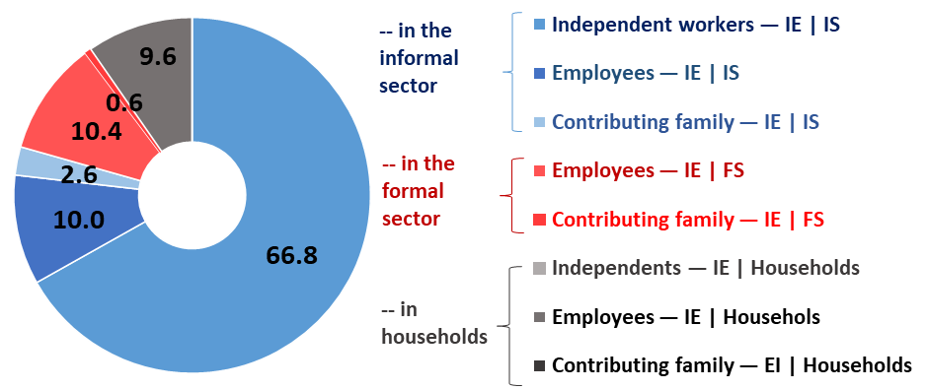

1. Who are the most exposed to informality?   
   “Share of informal employment for different groups”
   1. Percentage of informal employment by main personal characteristics

|  |  |  |
| --- | --- | --- |
| **A/Share of informal employment by level of education** | **B/Share of informal employment by age group** | **C/Share of informal employment by urban / rural** |
|  |  |  |

* 1. Percentage of informal employment by main employment related features

|  |  |
| --- | --- |
| 1. **Share of informal employment by status in employment** | 1. **Share of informal employment by detailed sector (the 10 sectors the most exposed to informality)** |
|  |  |

*OAW=Own-account workers

|  |  |
| --- | --- |
| 1. **Share of informal employment by size of enterprise and the formal and informal nature of the enterprise** |  |
|  |  |

|  |  |
| --- | --- |
| 1. **Informality and place of work: % of informal employment among 1) Home-based workers (own-home) and 2) Domestic workers (others’ home)** | 1. **Distribution of informal employment among 1) Home-based; 2) Domestic workers by sex** |
|  |  |

1. Who are the most represented as part of workers in informal employment?   
   “Distribution of informal employment by personal & employment related features”
   1. Distribution of informal employment by main personal characteristics

|  |  |
| --- | --- |
| 1. **Distribution of informal and formal employment by level of education** | 1. **Share of informal employment by rural / urban** |
|  |  |

* 1. Distribution of informal employment by main employment related features

|  |  |
| --- | --- |
| 1. **Distribution of informal and formal employment by status in employment** | |
|  | |
| 1. **The 10 sectors the most represented among workers in informal employment** | 1. **Distribution of informal employment by size of enterprise** | |
|  |  | |

1. Working conditions and informal employment: extent of decent wok deficits

|  |
| --- |
| 1. **Income security: wages among employees** and profit among independent workers **(compared to minimum wage)** |
| |  |  |  |  |  |  |  |  |  | | --- | --- | --- | --- | --- | --- | --- | --- | --- | |  |  | **FORMAL employment** | |  |  | **INFORMAL employment** | | | |  |  | **Total** | **Men** | **Women** |  | **Total** | **Men** | **Women** | | **Employees** | < 1/2 mnimum wage | 5,6 | 3,7 | 11,7 |  | 21,1 | 20,1 | 26,6 | | 1/2-Minimum Wage - Minimum wage | 24,4 | 22,0 | 31,8 |  | 35,2 | 33,0 | 47,5 | | Minimum Wage - 2 times Min Wage | 46,2 | 46,9 | 44,0 |  | 35,2 | 37,9 | 19,8 | | More than 2 times Minimum wage | 23,8 | 27,4 | 12,6 |  | 8,5 | 8,9 | 6,1 | | Total | 100,0 | 100,0 | 100,0 |  | 100,0 | 100,0 | 100,0 | | **Independent workers** | < 1/2 mnimum wage | 3,5 | 2,9 | 5,8 |  | 23,6 | 14,4 | 48,6 | | 1/2-Minimum Wage - Minimum wage | 11,8 | 10,4 | 17,3 |  | 31,6 | 33,1 | 27,8 | | Minimum Wage - 2 times Min Wage | 31,2 | 31,6 | 29,5 |  | 31,6 | 36,8 | 17,5 | | More than 2 times Minimum wage | 53,5 | 55,1 | 47,5 |  | 13,2 | 15,7 | 6,1 | | Total | 100,0 | 100,0 | 100,0 |  | 100,0 | 100,0 | 100,0 | |

|  |
| --- |
| 1. **Working time: Exposure to short/ very short hours or to long/ very long hours** |
|  |

|  |  |
| --- | --- |
| 1. **Representation security: unionization among employees** | 1. **Employment security: Percentage of informal employment depending on the type of contract** |
|  |  |

1. Contextual vulnerabilities:
2. **The household dimension**

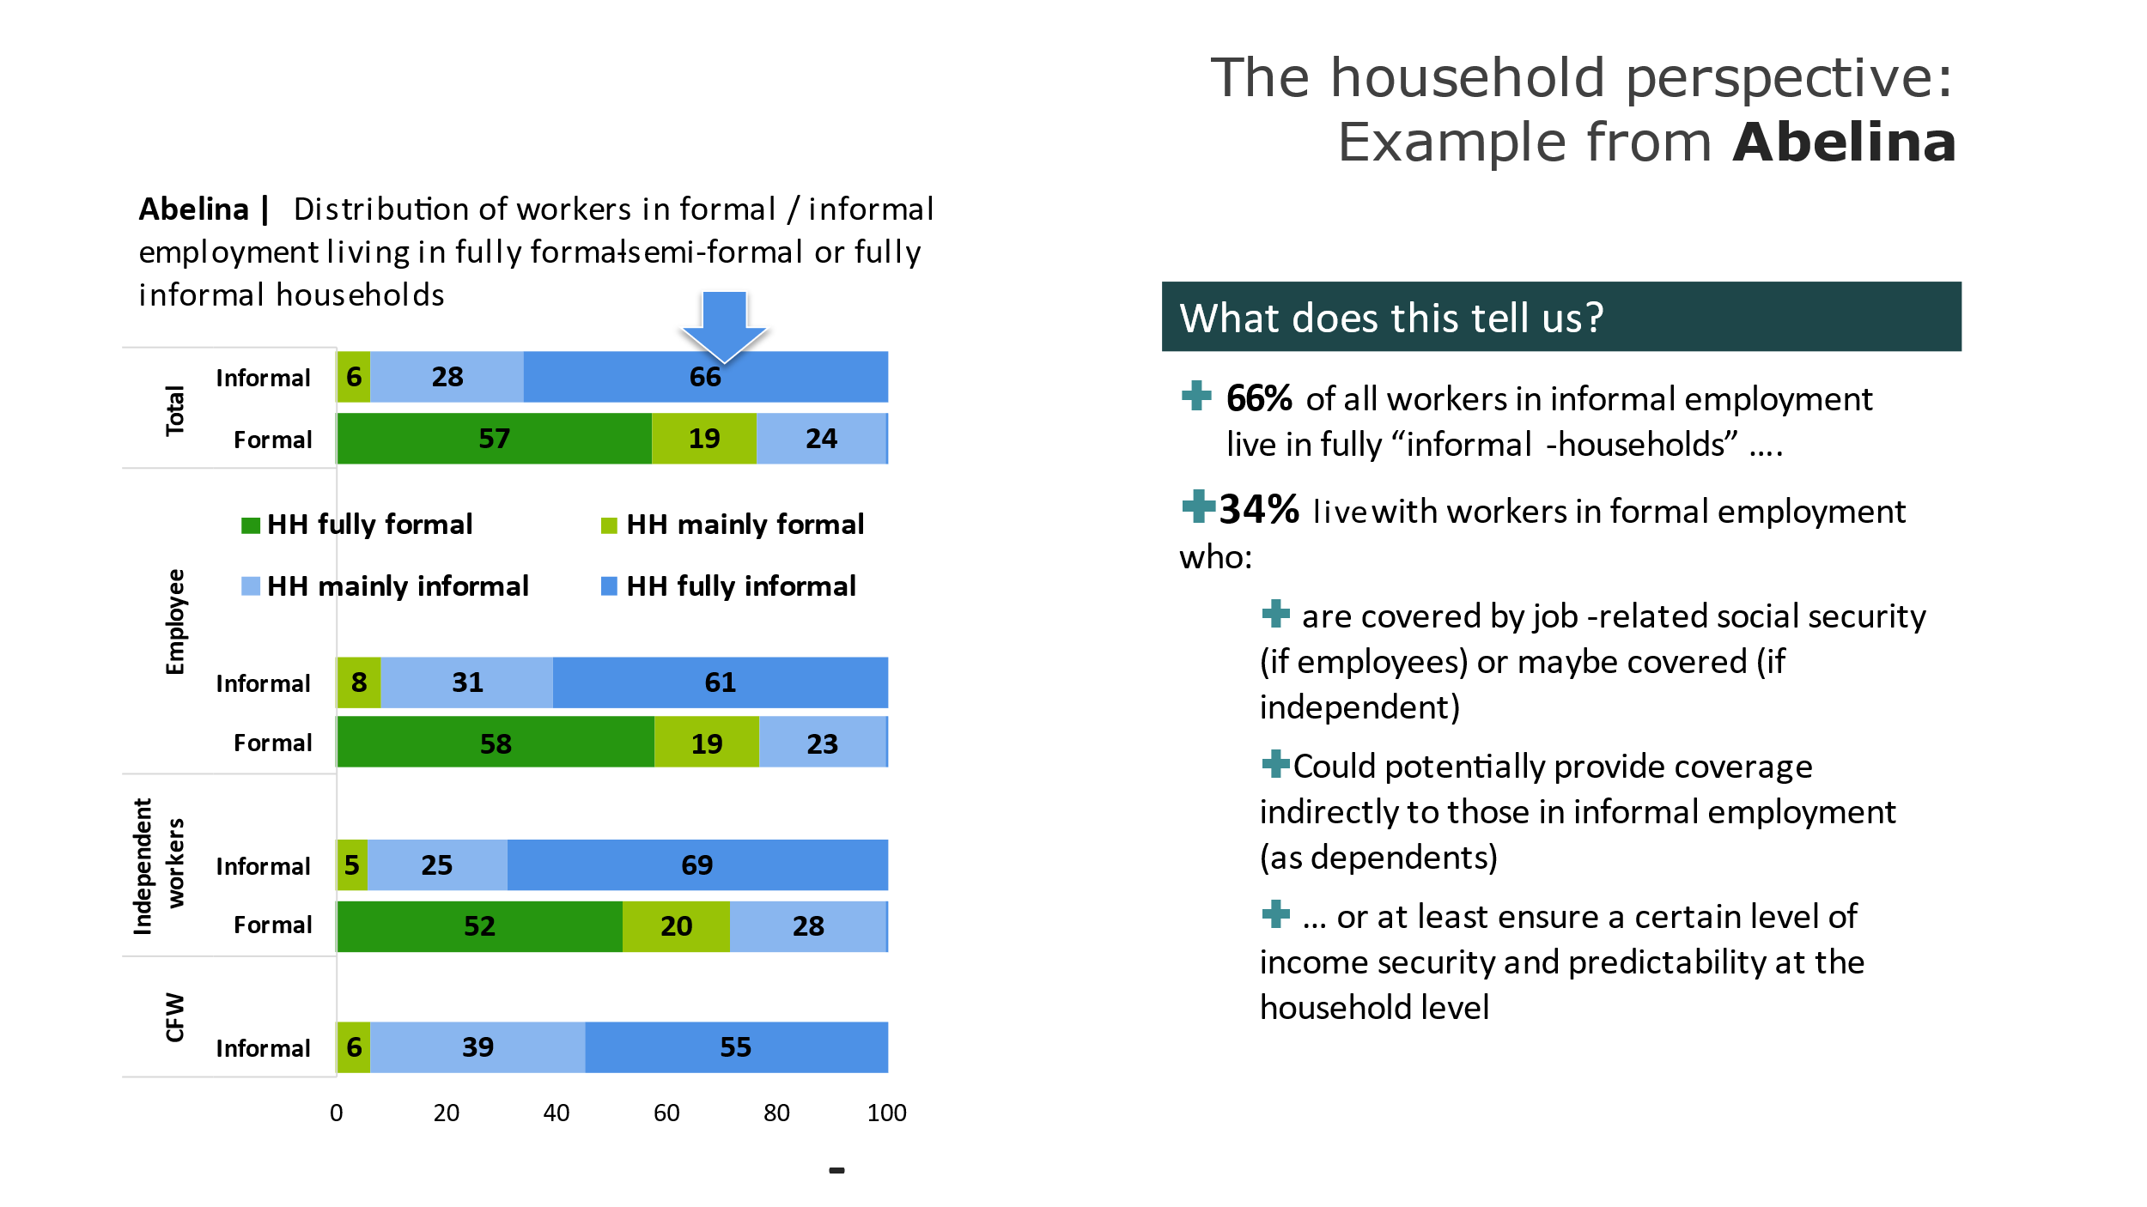

1. **Income poverty: workers in informal employment or in formal employment living in poor households**

|  |  |  |  |  |  |
| --- | --- | --- | --- | --- | --- |
| Sector | Sex |  | Formal employment | Informal employment | Total |
|  | **Agriculture** | **Poor** | **25,0** | **44,2** | **43,4** |
|  |  | Non-poor | 75,0 | 55,8 | 56,6 |
|  | **Industry** | **Poor** | **7,4** | **22,6** | **16,2** |
|  |  | Non-poor | 92,6 | 77,4 | 83,8 |
|  | **Services** | **Poor** | **5,7** | **18,1** | **11,2** |
|  |  | Non-poor | 94,3 | 81,9 | 88,8 |
|  | **Total** | **Poor** | **6,6** | **29,6** | **20,4** |
|  |  | Non-poor | 93,4 | 70,4 | 79,6 |

1. **Legal and regulatory frameworks**

* **Labour protection and social security: Assessment of the legal coverage gap and implementation gap**

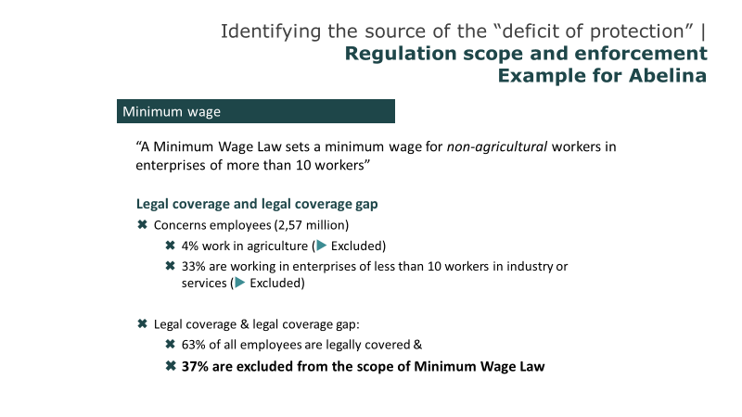

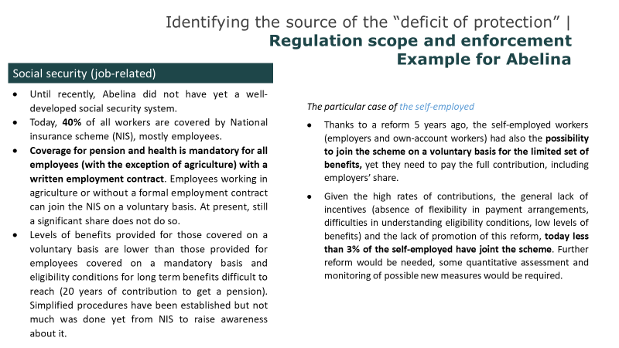

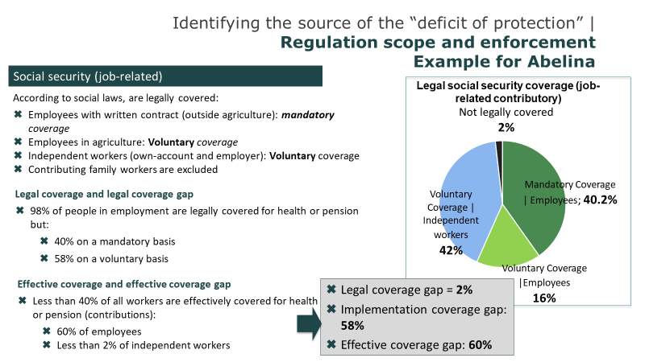

* **Additional information to assess the levels of protection or levels of vulnerabilities**

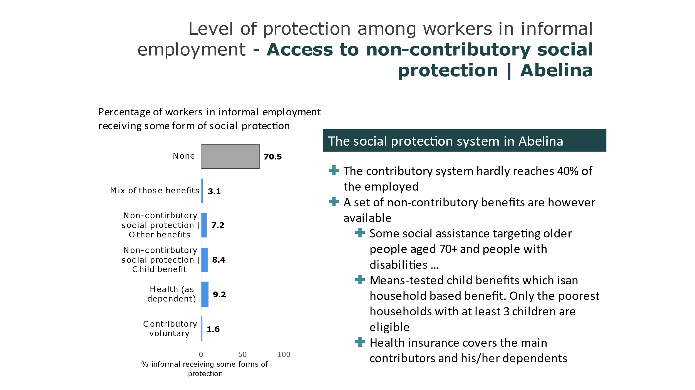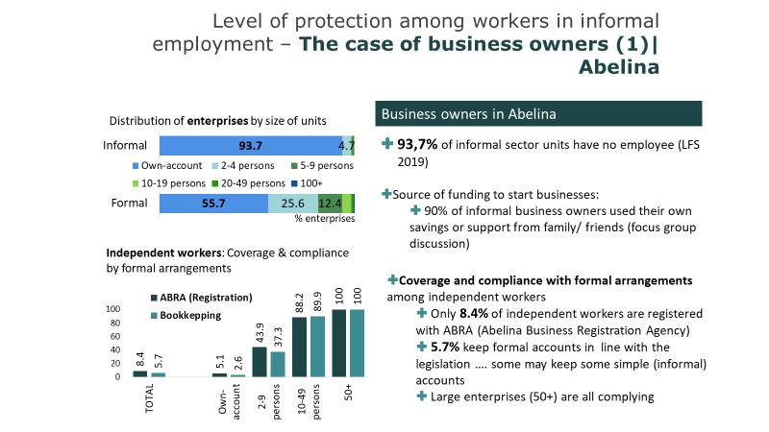

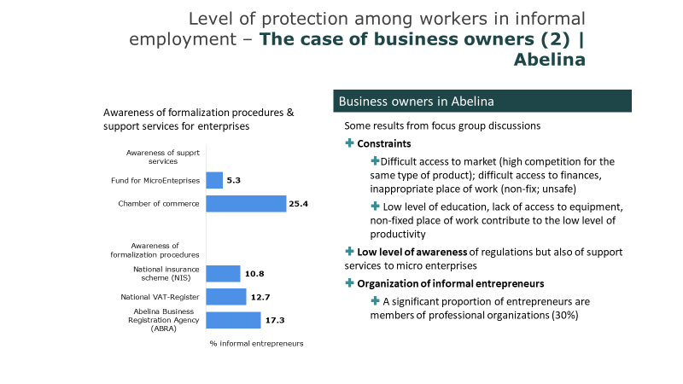

1. 1 ABD (Abelina dollar = 0.017 USD)